EBA5004 Continuous Assessment

Group 8 Proposal

ShopBot

|  |  |
| --- | --- |
| **Team Members** | |
| Shashank Nigam | A0198469A |
| Lin Wenqi | A0198435R |
| Ng Mei Ying | A0198546L |
| Edmund Leow Kwong Wei  **TEAM MEMBERS**  Edmund Leow Kwong Wei  Ng Mei Ying  Wilson Lum Kok Keong A0198478A  M A S T E R O F TECH N O L O G Y  P R O J E C T R E P O RT    T E A M M E M B E R S  Edmund Leow Kwong Wei - 1  Ng Mei Ying - 2  Wilson Lum Kok Keong - 3  M A S T E R O F TECH N O L O G Y  P R O J E C T R E P O RT    T E A M M E M B E R S  Edmund Leow Kwong Wei - 1  Ng Mei Ying - 2  Wilson Lum Kok Keong - 3 | A0198458H |

# Business Problem

In today’s world, traditional shopping is declining year-on-year, while e-commerce has been rising and is expected to reach 2.05 billion buyers globally by 2020 [1]. This has led to a much greater variety of products at lower prices, as multiple sellers across different countries compete for a slice of the market [2].

However, in a bid to differentiate their products, retailers often advertise their features with marketing jargon that adds to consumer confusion [3]. In addition, with the plethora of online marketplaces [4], even after deciding on the “best item” item, the consumer needs to decide which platform has the “best” price. All these factors result in consumer confusion and decision paralysis, where consumers experience greater anxiety and stress, and sometimes “buyers’ regret” after purchase, fearing that they have not chosen the “best” possible product [5, 6]. Overwhelmed with choices and decisions, they may even delay or stop shopping all together [7].

In particular, there has been a surge in demand for headphones in the last few years. More than one million headphones were sold per day in 2018 and sales are expected to increase by two-fold in 2024 [8]. Consumers are no longer content with standard earphones that are bundled with mobile phones or MP3 players, and headphones and earphones have become lifestyle accessories for the trendy. Confronted with a large variety of product models, consumers may not always understand the different specifications or find it tedious browsing through countless items to find the product that best suits them.

# Proposed Solution

We will build a product recommendation chatbot to give users better “decision simplicity” in their shopping. The chatbot has the following functions:

* Identifies user’s preferences during conversation
* Obtains sentiment from product reviews
* Provides product recommendations based on preferences (e.g. long battery life, suitable for sports, etc)
* Provides explanation of terminology for the product (e.g. certain technical specifications that the user might not be familiar with)
* Provides prices of chosen product across multiple shopping websites.

The scope is restricted to the following:

* Headphones and earphones
* Data retrieved from up to three shopping websites (eg Amazon, Lazada, Qoo10)
* Caching of results for top ten items in each category for product recommendation
* Dynamic retrieval of latest prices

# Datasets and Possible Techniques

The major intent and feature of the chatbot is product recommendation. This requires (A) sentiment analysis of reviews using a deep neural network, (B) text mining of reviews and websites for (i) aspect/information extraction of product features and (ii) topic modelling of reviews to uncover important words for a chosen product, and (C) a conversational interface to converse with users and identify their needs. *Table 1* summarises the proposed chatbot intents.

Several datasets would be utilised for this project. The Amazon Review Data (2018) which contains reviews from 1996 to 2018 [8] as well as reviews of headphones and earphones from Amazon extracted from an API would be used for sentiment analysis. In addition, the list of available products to recommend is retrieved through web-scraping or API calls of review websites and online marketplaces. The list of dataset sources is summarised in

*Table* 2.

Table 1. Chatbot intents and descriptions

|  |  |
| --- | --- |
| Chatbot Intent | Description |
| Product recommendation | Select suitable products according to rating, sentiment and product features deemed important to user |
| Product pricing | Call APIs from various online shopping platforms to get product information including price, and display link to purchase website in chatbot |
| Explanation of terminology | Shortlist typical terminology and store the terms into a lookup table; if term is not found, perform Google/Wikpedia search query |

Table 2. Dataset sources and usage

|  |  |  |
| --- | --- | --- |
| Purpose | Dataset source | Dataset type |
| Sentiment Analysis | Amazon Reviews (2018) dataset from  <https://nijianmo.github.io/amazon/index.html>  Headphone and earphone reviews from Amazon | Text |
| Information extraction | Product review websites | Text |
| Aspect extraction | Headphone and earphone reviews from Amazon | Text |
| Topic modelling | Headphone and earphone reviews from Amazon | Text |
| Short-listing of products | Shopping websites (Amazon, Qoo10, Lazada, etc)  Review websites | Text,  product IDs |
| Product Pricing | Google Shopping API  Shopping websites APIs | Prices |
| Trending products | Google Trends | Text |

# Proposed Architecture

A fairly standard chatbot architecture comprising a Chat UI, chatbot backend and cloud Platform-as-a-service (PaaS) is proposed in *Figure 1*. The major components of the system are the chatbot and sentiment mining module.

The sentiment mining module uses product reviews and the results are stored in a database. At runtime, relevant products are retrieved and presented to users based on their preferences.

The chatbot identifies intents, and performs entity detection and dialogue management, with custom intents and entity modules developed for greater control and flexibility. This will help to trigger fallback intents correctly, parse and validate parameters, and also redirect the flow of conversation when the user changes his intent.

The list of modules and their interactions are shown in *Figure 2*.



Figure 1. Proposed overall architecture for shopBot system

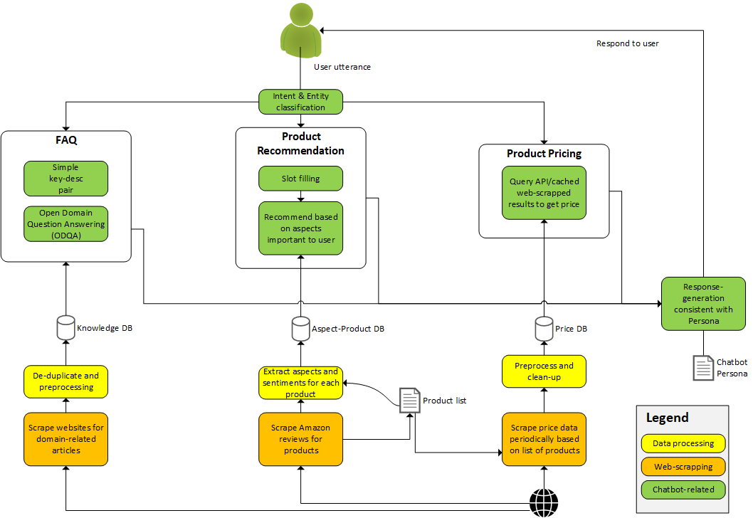

Figure 2. Proposed modules for shopBot system

# References

|  |  |
| --- | --- |
| [1] | Oberlo, “Find out How Many People Shop Online in 2020,” [Online]. Available: https://www.oberlo.com/statistics/how-many-people-shop-online. |
| [2] | “The growth of e-commerce means more choice and better deals,” The National, 2 Jan 2018. [Online]. Available: https://www.thenational.ae/opinion/editorial/the-growth-of-e-commerce-means-more-choice-and-better-deals-1.692313. |
| [3] | R. Carter, “Lost in translation: The dangers of marketing jargon,” Fabrik Brands, 1 Aug 2019. [Online]. Available: https://fabrikbrands.com/the-dangers-of-marketing-jargon/. |
| [4] | “The biggest online marketplaces that you should know,” IONOS, 6 8 2019. [Online]. Available: https://www.ionos.com/digitalguide/online-marketing/online-sales/the-biggest-online-marketplaces-that-you-should-know/. |
| [5] | B. Schwartz, The paradox of choice : why more is less, New York: Ecco, 2004. |
| [6] | L. M. Lyengar S, “When choice is demotivating: Can one desire too much of a good thing,” *Journal of Personality and Social Psychology,* vol. 79, pp. 995-1006, 2000. |
| [7] | Knowledge@Wharton, “Online Shopping Choices: Less Is Sometimes Better Than More,” Wharton University of Pennsylvania, 17 Dec 2013. [Online]. Available: https://knowledge.wharton.upenn.edu/article/online-shopping-choices-less-sometimes-better/. |
| [8] | A. A. &. Intelligence, “Global Earphones and Headphones Market to Reach Values of $36 Billion During the Period 2018−2024,” PRNewswire, 14 Feb 2019. [Online]. Available: https://www.prnewswire.com/news-releases/global-earphones-and-headphones-market-to-reach-values-of-36-billion-during-the-period-20182024--market-research-by-arizton-300795642.html. |
| [9] | J. Ni, “Amazon Review Data (2018),” University of California San Diego (UCSD), 2018. [Online]. Available: https://nijianmo.github.io/amazon/index.html. |